- Create topic using kafka docker
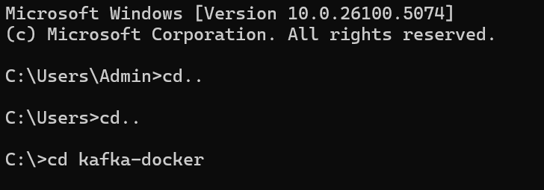
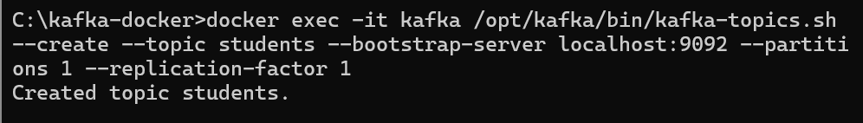
- Create producer using kafka docker
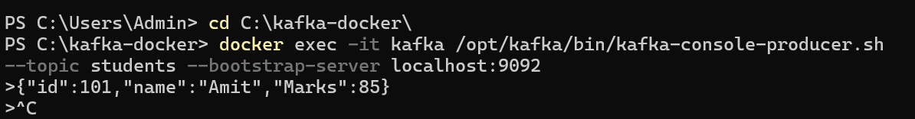
- Create Consumer using kafka docker
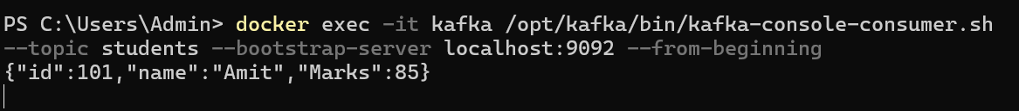
- Connect to kql database server
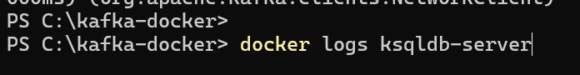
- Execute KsqlDB and creation of stream with output
